**Challenge-6**

**Create ci pipeline that will deploy and configure these VMs using terraform and ansible according following requirements**

1. **Deploy 2 virtual machines using terraform.**
   * **first vm on Amazon linux, hostname: c8.local**
   * **second vm on ubuntu 21.04, hostname: u21.local**
2. **As a result of terraform execution, dynamically create inventory for ansible**
   * **c8.local should be in the frontend group**
   * **u21.local should be in the backend group**
3. **Create ansible playbook for c8.local and u21.local**
4. **for linux OS playbook should apply the following changes**
   * **selinux: disable**
   * **firewalld: disable**
5. **for frontend playbook group should install and configure nginx**
   * **nginx configuration should do proxying from port 80 on port 19999 to the**
   * **backend group**
6. **for the backend group, the playbook must install the Netdata application from the**
   * **official repositories and run it on port 19999.**

**--------------------------------------------------------------------------------------------------------------------------------**

**1.Create Ec2 instance with t2 large with 20gb volume**

**Install Git, Terraform, Ansible**

To install **Terraform** on **Ubuntu**, you can follow these steps:

**1. Update and install prerequisites**

sudo apt-get update && sudo apt-get install -y gnupg software-properties-common curl

**2. Add the HashiCorp GPG key**

curl -fsSL https://apt.releases.hashicorp.com/gpg | sudo apt-key add -

**3. Add the official HashiCorp Linux repository**

sudo apt-add-repository "deb [arch=amd64] https://apt.releases.hashicorp.com $(lsb_release -cs) main"

**4. Install Terraform**

sudo apt-get update && sudo apt-get install -y terraform

**5. Verify installation**

terraform -version

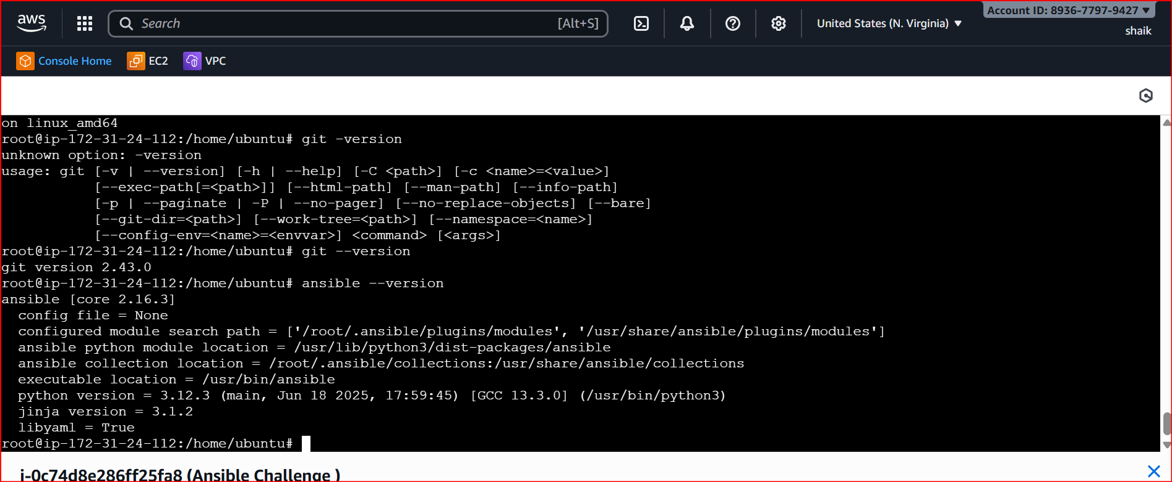



<https://github.com/Shaik123-hu/ci-terraform-ansible.git>

clone this url

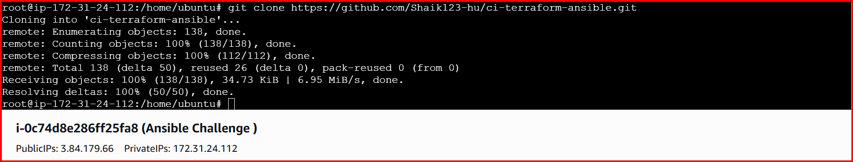

Cd ci-terraform-ansible

Cd terraform

Vi variables.tf

In this file edit the region, pemkey, and ami ids

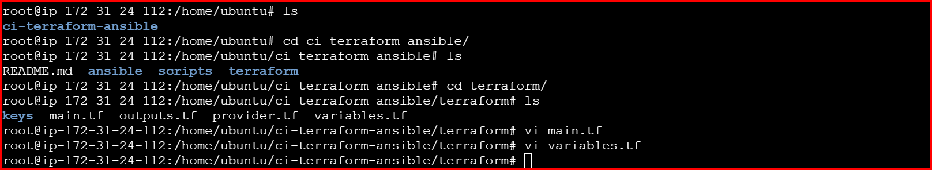

You can install the **AWS CLI v2** on **Ubuntu** with these steps:

**1. Update system**

sudo apt-get update -y

**2. Install unzip (needed to extract AWS CLI package)**

sudo apt-get install -y unzip curl

**3. Download AWS CLI v2 package**

curl "https://awscli.amazonaws.com/awscli-exe-linux-x86_64.zip" -o "awscliv2.zip"

**4. Unzip the installer**

unzip awscliv2.zip

**5. Run the installer**

sudo ./aws/install

**6. Verify installation**

aws --version

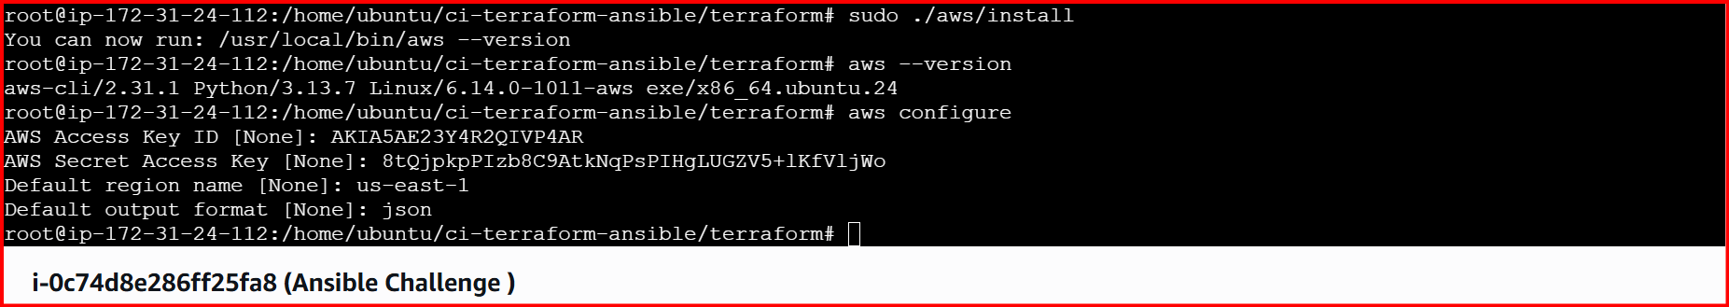

Terraform init

Terraform apply

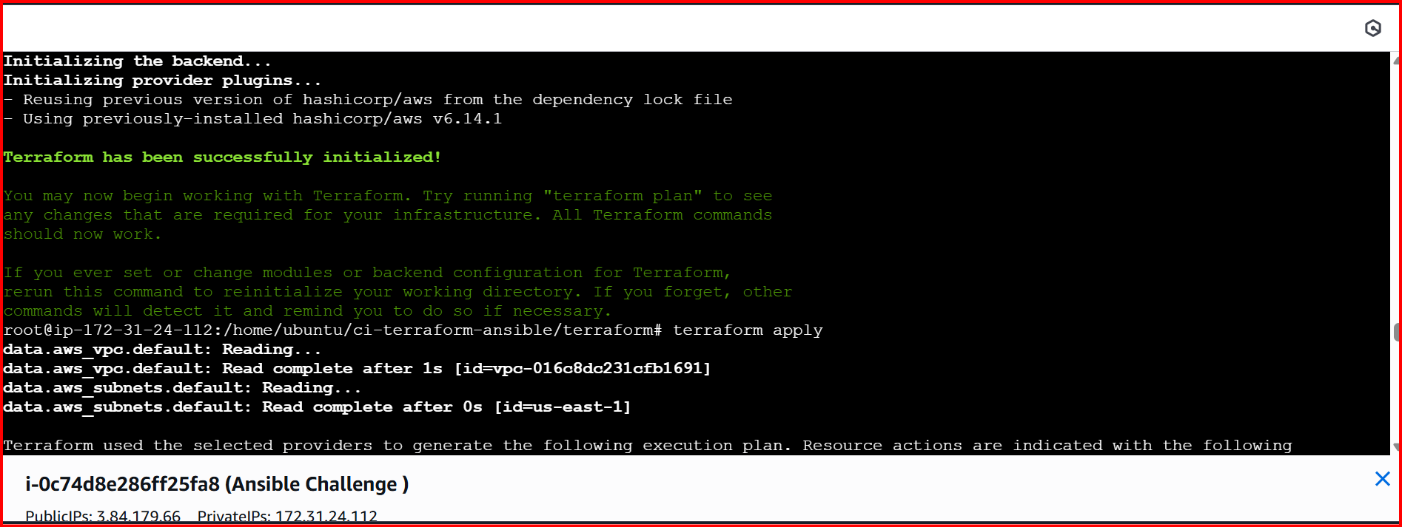

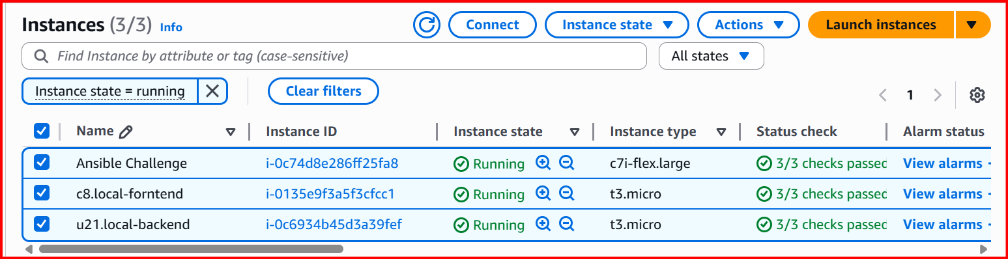

cd ansible

vi generate_inventory.py

chmod +x generate_inventory.py

./generate_inventory.py

./generate_inventory.py file is not executed/ go to below path and execute

/home/ubuntu/ci-terraform-ansible/terraform# terraform output -json > inventory.json

Come back to ansible path:

./generate_inventory.py this time it will work

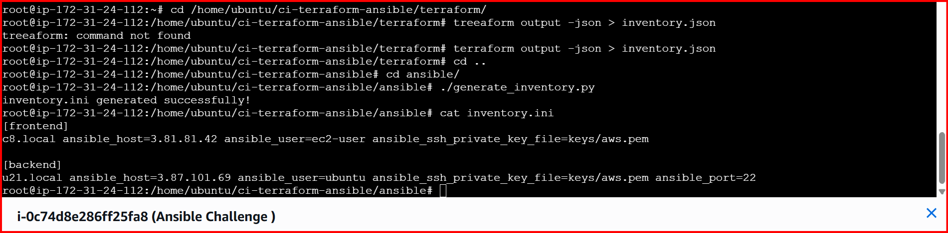

Cat inventory.ini

Cd keys

ls

vi aws.pem (your pem_key)

chmod 600 aws.pem

root@ip-172-31-24-112:/home/ubuntu/ci-terraform-ansible/ansible#

run this command

ansible -i inventory.ini all -m ping

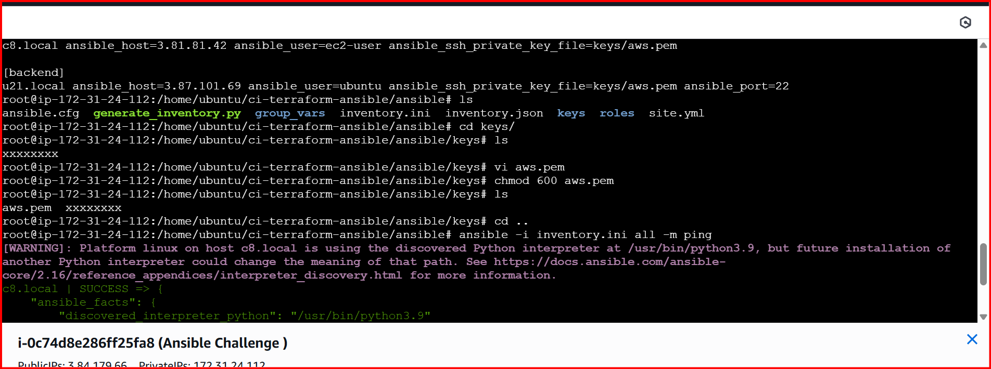

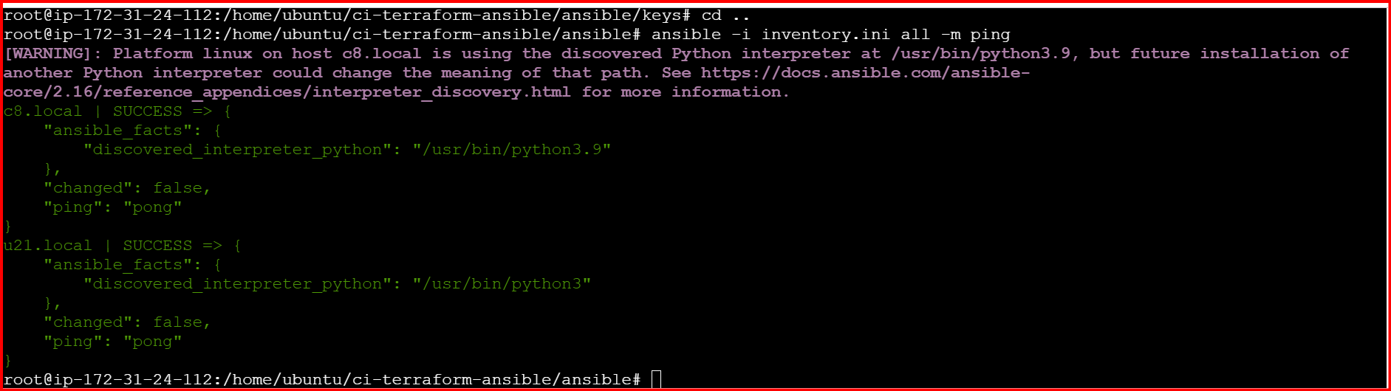

root@ip-172-31-24-112:/home/ubuntu/ci-terraform-ansible/ansible#

ansible-playbook -i inventory.ini site.yml -u ubuntu –become

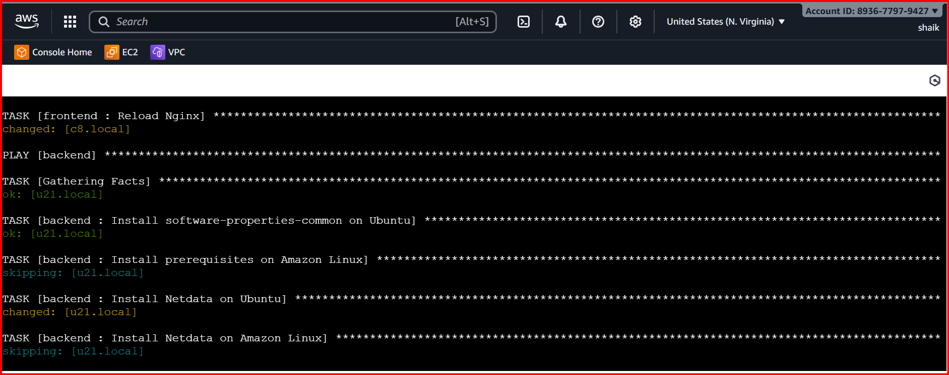

root@ip-172-31-24-112:/home/ubuntu/ci-terraform-ansible/ansible#  
  
create vi disable.yml

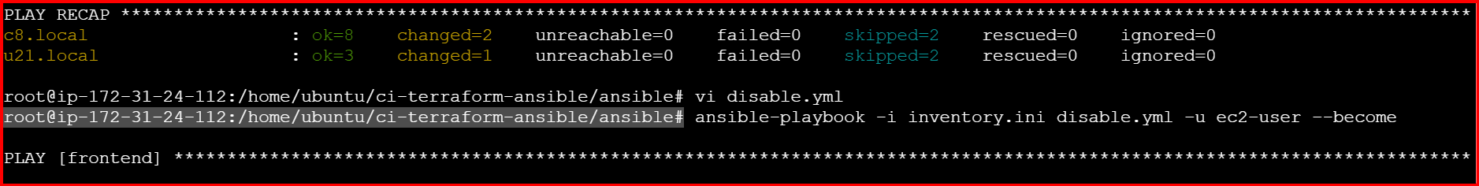

- hosts: frontend

become: yes

tasks:

- name: Disable SELinux permanently

selinux:

state: disabled

- name: Set SELinux to permissive mode

command: setenforce 0

when: ansible_selinux.status == "enabled"

- name: Disable firewalld

systemd:

name: firewalld

state: stopped

enabled: no

ignore_errors: yes

failed_when: false

ansible-playbook -i inventory.ini disable.yml -u ec2-user --become

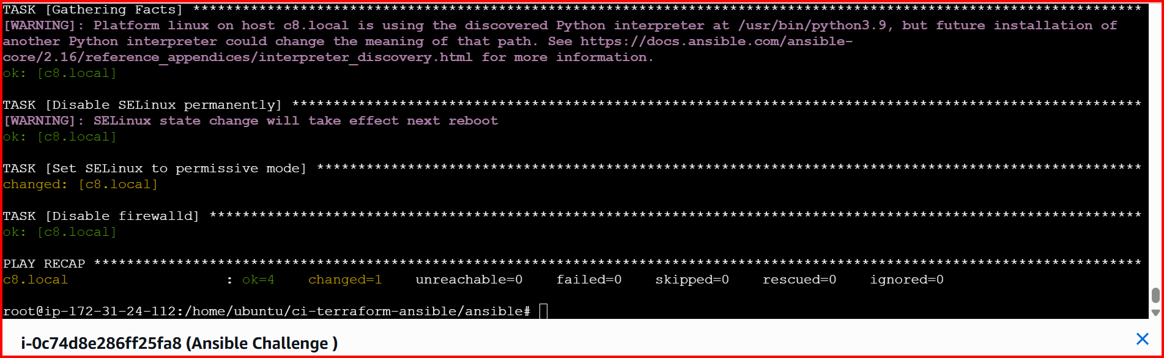

1. for linux OS playbook should apply the following changes
   * selinux: disable
   * firewalld: disable

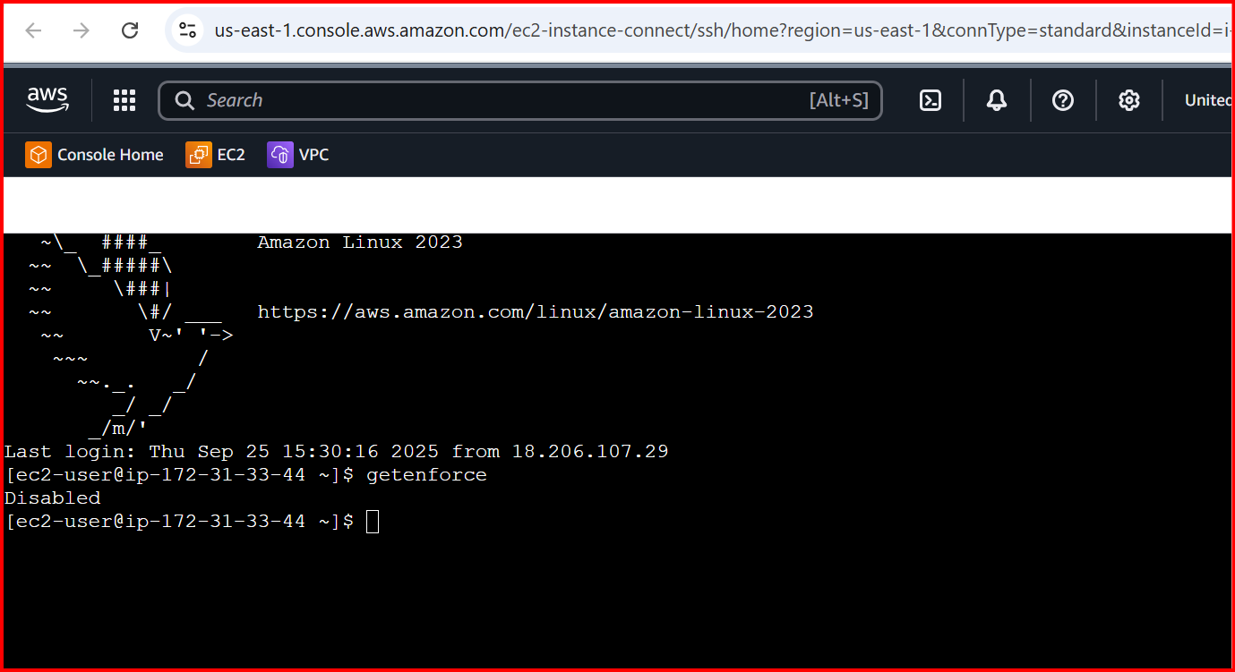

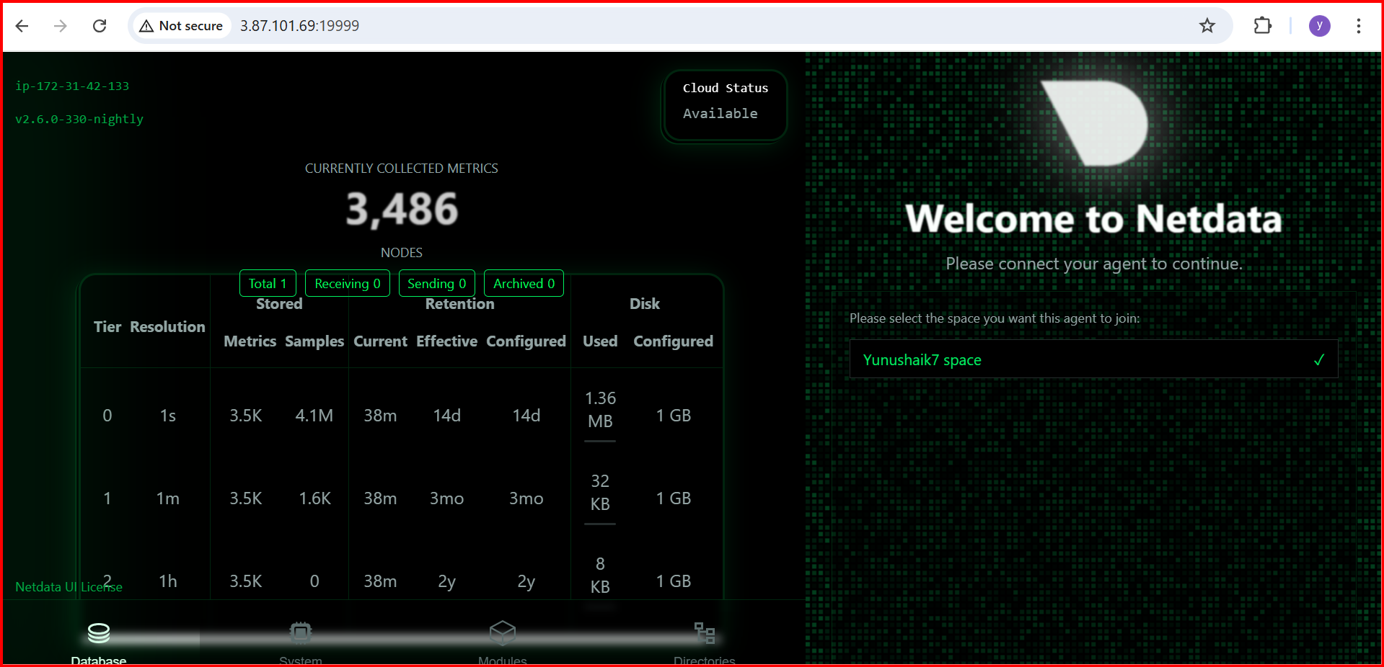

**✅ Fix: Connect Agent to Netdata Cloud**

1. Log in to **Netdata Cloud**: https://app.netdata.cloud.
2. Create/select your space (**Yunushaik7 space** in your screenshot).
3. On your server, run the Netdata claim command:

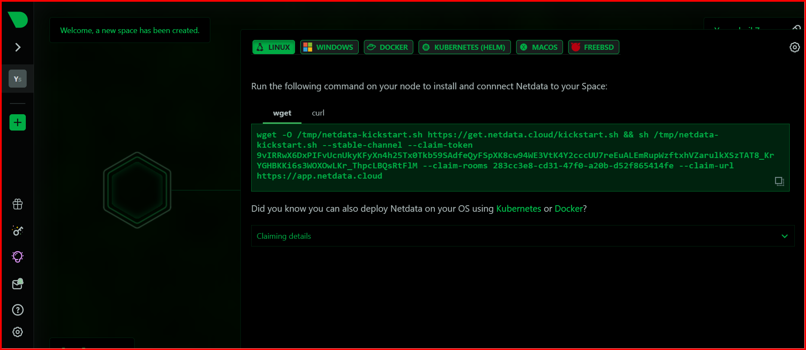

**(u21.local) give the wget command**

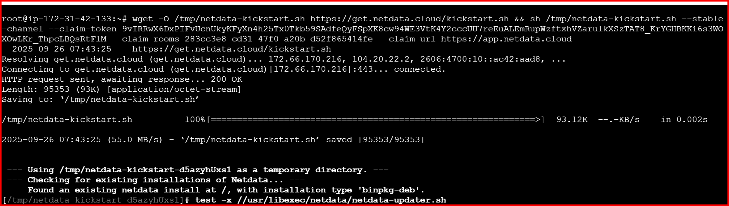

**Refresh the browser**

